LOUVRE KIT M1 (06)
Installation Instructions

COMPONENTS

Right hand fitment (with opening handle) 1
Left hand fitment 1
Cropped Fixing Bolts and Nuts 4

Existing Pane
“X”
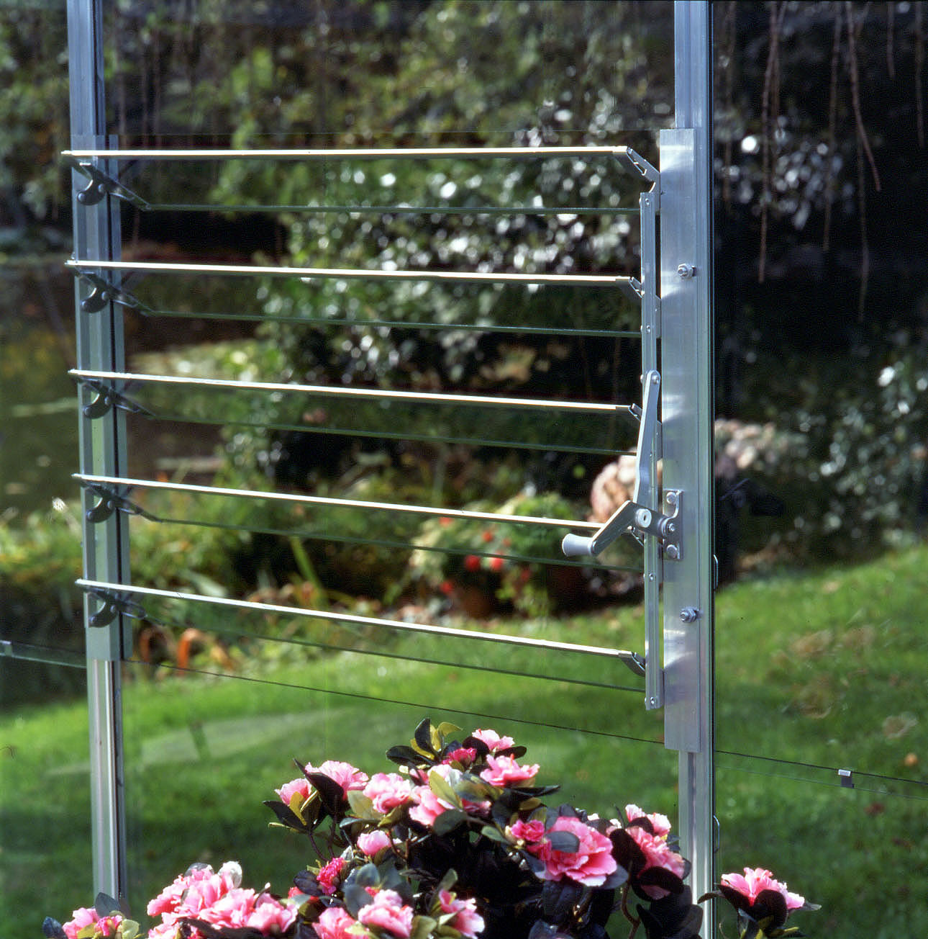

444mm

Special Pane
View from inside
Greenhouse Base & Sill Viewed from Outside
The
Removed Pane

Please take care when handling glass and always wear gloves.
Once the glass has been cut to size we strongly advise that all sharp edges are removed using fine emery cloth.

Remove the pane of glass you wish to replace with the Louvre Window.

Measure the removed pane and make a note of the dimensions.

You will require five pieces of glass for the Louvre blades:

100mm by “X” minus 30mm

You will also require an additional piece of glass for the Special Pane:

“Y” minus 444mm by “X”

“Y”

“X”
1. From the inside of the greenhouse bolt in the two fitments to the glazing bars using the cropped bolts supplied.
2. The top of the fitments should butt up to the lower edge of the pane above.
3. Fit the Special Pane below the Louvre fitments.
4. Slip the five Louvre blades into the retaining clips
You should report any problems relating to the product within 7-10 days from receipt.

